**CHARACTERISTICS OF THE CLIFF PLANT COMMUNITIES OF THE TUAPKHAT MASSIF**

***Sergey Krylenko, SC “Erudit”,*** [***krylenkoserg@mail.ru***](mailto:krylenkoserg@mail.ru)

**Abstract. Preservation of biological diversity is necessary for sustainable development and rational use of coastal resources. In this paper structure of the cliff plant communities of the massif Tuapkhat (the Black Sea coast, Russia) are characterized. Flora of this coastal zone combines features of Mediterranean and middle European Russia types. Herbaceous and shrub life-forms and xeromorphous and petrophilous plant associations dominate at the studied area. The main factor determining the species composition of the examined communities is substrate character.**

*Key words: cliff, plant communities, Black sea coast, ecotop.*

**I. Introduction**

Preservation of biological diversity is one of the most important factors of a sustainable development and rational use of natural resources. A variety of a plant cover structure is characteristic of mountainous areas with high differentiation of habitats [1]. For preservation of a biodiversity of coastal zone landscapes of mountainous areas it is necessary to know structure of the plant communities growing in these places. In this paper features of structure of the coastal zone plant communities of the massif Tuapkhat (the Black Sea coast of Krasnodar region, Russia) are characterized.

The main part of the Tuapkhat massif coast is an abrasion cliff up to 100 m high and is crossed by deeply valleys. The constituting rocks are represented by Cretaceous flysch composed of alternating marlstones, limestones and mudstones [2]. Colluvial deposits on the cliff consist of large-fragmental material with trace impurity of gravel and loam [3]. The soil is on the cliff underdeveloped, gravelly, with a small amount of humus. Adjacent to coast area is covered mainly by pine forests and scrub growths consisting of xerophytic species. Flora of this coastal zone vegetation communities combines features of Mediterranean and middle European Russia types [2].

II. Structure of plant communities

The field researchers are realized directly on the coastal cliff. Seventy seven species of plants are found on investigated area [1, 4, 5, 6] (Таb. 1). Five specific ecotopes of investigated coastal area are identified. They are allocated depending on the understratum structure.

The first singled out ecotope, which is the smallest of all singled out ecotopes, is cliff taluses formed by colluvium. They represent poorly connected and moving substratum consisting of small detritus of marl and limestone rocks (Fig. 1). They are formed under clefts in plates where soft marl layers which yield to weathering easily get revealed. Due to dynamism of this ecotope there is no soil cover forming process in it. Plants grow mostly on the base and side edges of the cone talus. Because of the absence of soil and small territory of possible vegetation cliff taluses are characterized by an extremely low diversity of growing plants. On the examined territory within the given ecotope there were detected six species (Table 1) two which are dominant: *Onosma polyphylla* and *Euphorbia petrophila* and the rest belong to not numerous species. *Seseli ponticum* is mostly represented by annual plantlets that can probably be explained by the fact that the seeds that get there germinate but can’t get stronger after germination and die. All these plants are hemicryptophytes.

Table 1. Composition of the plant communities of the ecotopes.

| Plant | Cliff talus | Landslide | Plane of layer | Vertical cleft | Horizontal cleft |
| --- | --- | --- | --- | --- | --- |
| *Agropyron pinifolium* |  | + |  |  |  |
| *Allium atroviolaceum* |  | ++ |  |  |  |
| *Allium globosum* |  |  | ++ |  | ++ |
| *Alyssum calycinum* |  | + | + |  | + |
| *Arabis recta* |  | + |  |  | ++ |
| *Asperula arvensis* |  | + |  |  |  |
| *Asperula lipskyana* |  | ++ | + |  | + |
| *Asphodeline taurica* |  | ++ |  | + | + |
| *Astragalus circassicus* |  | + |  |  |  |
| *Astragalus denudatus* |  |  |  | ++ | ++ |
| *Astragalus subuliformis* |  |  | + |  |  |
| *Astragalus utriger* |  | + |  | + | + |
| *Campanula komarovii* |  | + |  |  |  |
| *Caragána arboréscens* |  | ++ |  |  |  |
| *Cardaria draba* |  | ++ |  |  |  |
| *Carex distans* |  | ++ |  |  |  |
| *Cárpinus bétulus* |  | + |  | + |  |
| *Centaurea leucophylla* |  |  |  |  | + |
| *Cerastium arvense* |  | ++ |  | + | + |
| *Chondrilla juncea* |  | ++ |  |  | +++ |
| *Convolvulus cantabrica* | + | ++ |  |  |  |
| *Coronilla scorpioides* |  | + |  |  |  |
| *Córylus avellána* |  | + |  |  |  |
| *Cotinus coggygria* |  | ++ |  | + |  |
| *Cruciata coronata* |  | + |  |  |  |
| *Cruciata laevipes* |  | + |  |  |  |
| *Cruciata taurica* |  | ++ |  |  |  |
| *Dorycnium herbaceum* |  | + |  |  |  |
| *Erysimum cuspidatum* |  | ++ |  |  | ++ |
| *Euphorbia petrophila* | +++ | + | + |  | + |
| *Festuca rupicola* |  | + |  |  |  |
| *Fraxinus excelsior* |  | + |  |  |  |
| *Fumaria officinalis* |  | + |  |  |  |
| *Galium biebersteinii* |  |  |  | + |  |
| *Helianthemum ovatum* |  |  |  |  | + |
| *Inula ensifolia* |  |  | + | ++ | + |
| *Juniperus oxycedrus* |  |  | + |  |  |
| *Lamyra echinocephala* | + | + | + | ++ | +++ |
| *Lappula barbata* |  | + |  |  |  |
| *Leontodon asperrimus* |  | + |  |  |  |
| *Lepidium campestre* |  | + |  |  |  |
| *Linum lanuginosum* |  | ++ |  |  |  |
| *Lolium rigidum* |  | + | + |  |  |
| *Matthiola odoratissima* | + | ++ | + | + | + |
| *Medicago lupulina* |  | ++ | + |  |  |
| *Melilotoides cretacea* |  | ++ | +++ | +++ | +++ |
| *Microthlaspi perfoliatum* |  | ++ |  |  |  |
| *Muscari armeniacum* |  | + |  |  | + |
| *Oberna crispata* |  | ++ |  |  | + |
| *Onosma polyphylla* | +++ |  |  |  | ++ |
| *Paliurus spina-christi* |  | + |  |  |  |
| *Períploca gráeca* |  |  |  |  | + |
| *Phrágmites austrális* |  | + |  | + |  |
| *Pinus pityusa* |  | + | + |  | ++ |
| *Poa sterilis* |  | ++ |  |  |  |
| *Polygala anatolica* |  | + |  |  |  |
| *Poterium polygamum* |  | + |  |  | + |
| *Prunus divaricata* |  | + |  |  |  |
| *Reseda lutea* |  | + |  |  |  |
| *Rhus coriária* |  |  |  | + |  |
| *Rósa canína* |  | + |  |  |  |
| *Rubus anatolicus* |  | + |  |  |  |
| *Salvia rigens* |  | ++ | + |  |  |
| *Scutellaria novorossica* |  | ++ |  |  | + |
| *Sedum reflexum* |  |  | + |  | + |
| *Seseli ponticum* | + | ++ | +++ | +++ | + |
| *Seseli dichotomum* |  |  | + |  |  |
| *Sideritis euxina* |  | ++ |  |  |  |
| *Smilax excelsa* |  | + |  |  |  |
| *Sonchus asper* |  | ++ |  |  |  |
| *Stípa capilláta* |  |  | + |  | + |
| *Thymus marschallianus* |  | + | + |  |  |
| *Tragopógon dúbius* |  |  |  |  | + |
| *Veronica filifolia* |  | + |  |  | + |
| *Veronica multifida* |  | + |  |  |  |
| *Vicia angustifolia* |  | ++ |  |  |  |

Second (largest in its territory ecotope) is represented by plane of the layers of sedimentary rocks which face sea with their front side (Fig. 1). This ecotope is resistant to weathering. This fact assists formation of underdeveloped crushed stone soils which are formed in numerous small clefts that transpierce the layers. Plants grow exactly in the clefts. All in all, there were 19 species detected within this ecotope (Table 1). The dominant species which are met with equal occurrence are *Seseli ponticum* and *Melilotoides cretacea*. A typical but less frequent species is *Allium globosum*. Other 16 species belong to not numerable ones. The species are distributed unevenly some of them are met in the limited parts of the ecotope. Three species are not met within other ecotopes. There are two wood species singled out of them which spread to the ecotope from the forests situated above the steeps: *Juniperus oxycedrus* and *Pinus pityusa*. Life forms of the plants are different: phanerophytes (*Pinus pityusa*), chamaephytes (*Seseli ponticum*), hemicryptophytes (*Lolium rigidum*) and cryptophytes (*Allium globosum*).

The third ecotope is situated at the butt ends of the plates situated vertically (Fig. 1). It is represented by vertical clefts covered by solid limestone rocks at the bottom and at the top and having soft, crumbling marl rocks in the middle.

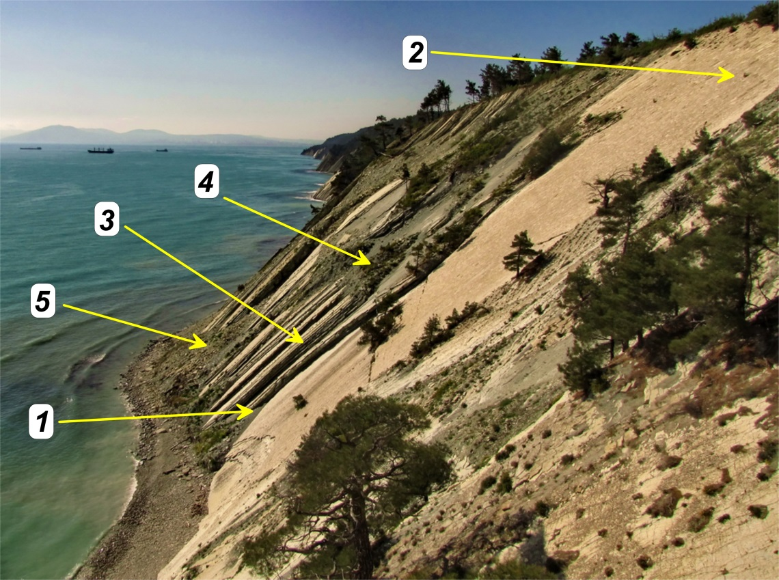

*Fig. 1. Ecotopes: 1- cliff talus, 2– plane of layer, 3- vertical cleft, 4- horizontal cleft, 5– landslide.*

The ecotope is dynamic as the medium marl layer crumbles all the time, and when the support is lost the upper limestone stratum is destroyed too. There is almost no soil cover which is formed mainly in the clefts on the edges of the solid stratum. Plants settle down mostly on the butt ends of the limestone rocks since marl rocks deteriorate quickly and it does not let plants to fix. There are 14 species of plants within this ecotope (Table 1) two of which can’t be met within other ecotopes. The dominate species are *Seseli ponticum* and *Melilotoides cretacea. Astragalus denudatus, Lamyra echinocephala* and *Inula ensifolia* refer to often met and characteristic species. Out of not numerous plant species one can single out bushy forms of *Cotinus coggygria, Carpinus betulus, Rhus coriaria, Asphodeline taurica* and *Phragmites australis* which are met only at the places of the emergence of ground water or streams. Life forms of plants are represented by phanerophytes (*Carpinus betulus*), chamaephytes (*Seseli ponticum*), hemicryptophytes (*Astragalus dedunatus*), cryptophytes (*Asphodeline taurica*) and therophytes (*Galium biebersteinii*).

The fourth ecotope is represented by horizontal clefts (Fig. 1). It is formed at the horizontal butt ends of the plates. Detritus (fragmentary material) stability assists in accumulation of the organic material and in the formation of the soil cover. This fact also explains its higher species diversity. 29 plant species grow within the ecotope (Table 1). Four of these species are not occur in other places of the cliff. The dominant place is occupied by *Lamyra echinocephala, Chondrilla juncea* and *Melilotoides cretacea.* Six species occur often. One of these species is *Pinus pityusa* which is represented by dwarf forms. Other species refer to not numerous ones. Life forms of the plants are represented by phanerophytes (*Pinus pityusa*), chamaephytes (*Lamyra echinocephala*), hemicryptophytes (*Astragalus dedunatus*), cryptophytes (*Muscari armeniacum*).

Extreme rain in 2012 near the Gelendzik city caused heavy landslides at the seashore. As a result, a new ecotope in the investigated region appeared. It was formed by landslide bodies which consist of large pieces of rock and marl (Fig. 1). The main characteristic feature of the ecotope is the soil which was preserved at the given areas of the landslide. Consequently, plants from the shibliak belt got to the cliff and on these territories there is higher species diversity in comparison with other ecotopes. 39 out of 68 species, which are met in plant communities of the given ecotope, can’t be met in other communities. These species are not characteristic for the cliff community and are covered together with the landslide body. These plants are characteristic for the vegetation of the shibliak communities which are situated over the steeps outside the cliff. Their survival at the cliff can be explained by the fact that during the landslide formation the soil cover was not damaged and the plants got down together with it continuing their growth afterwards. They formed the initial plant cover, within the next 4 years rocky vegetation occupied landslide bodies successfully and finally supplemented the plant communities. Mixed communities were formed out of the vegetation of the shibliak belt and the vegetation of the rocky communities. A community is considered to be polydominant, this feature was inherited from the shibliak community. 26 plant species are met equally in all landslide parts. Other species are not numerous but they are also met in all landslides parts. Life forms are represented by phanerophytes, chamaephytes, hemicryptophytes, cryptophytes and therophytes. Most likely, with the following deterioration of the landslide masses the species of the shibliak belt will disappear.

III. Conclusion

In the result of the researches it was found out that the cliff plant cover of the Tuaphat massif is heterogeneous. The existing plant communities vary greatly in their structure and species composition and belong to certain ecotopes. There are only three common plant species for the highlighted communities: *Lamyra echinocephal*a, *Seseli ponticum* и *Matthiola odoratissima*. 45 out of 77 discovered during the research species are met within one ecotope that indicates the uniqueness of the conditions of each ecotope. At the same time it is impossible to claim about complete isolation of the ecotopes as 32 species are able to exist within several ecotopes and the appearance of a mixed plant community on landslides indicates the active species exchange on the cliff. The plant communities formed on the landslides differ a lot from the structure of the aboriginal communities of the coastal zone. It is explained by great species diversity, marked species uniqueness and quantity structure of the community. The main abiotic factor that identifies species composition of the examined communities is a substrate type: the stoniness and humus content in the soil and the bedding angle.

IV. References

[1] O.N. Lipka, "Botanical diversity and current state of vegetation of the Markotkh ridge”: Northwest Caucasus", Moscow, 2006, 159 p. (in Russian).

[2] N.A. Grechushkina, "Communities with domination of *Rhus coriaria* on cliffs of the northwest coast of the Caucasus", News of the Samara scientific center, 2008, V. 10, № 2, p.400-406 (in Russian)

[3] V.V. Krylenko, R.D. Kosyan, M.V. Krylenko and I.S. Podymov, “Transport of solid material to the coastal zone near Gelendzhik after extremely heavy rains”, Oceanology, 2014, Vol. 54, No. 1, pp. 88–94.

[4] A.S. Zernov, "Plants of the Russian Western Caucasus", Moscow, 2010, 448 p. (in Russian).

[5] “Atlas of plants of Russia and adjacent countries”, http://www.plantarium.ru/

[6] K. Nidon, I. Peterman, P. Sheffel, B. Shayba, "Plants and animals", Moscow, 1991, 259 p.